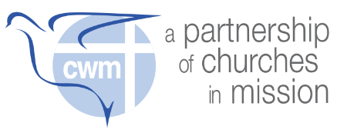
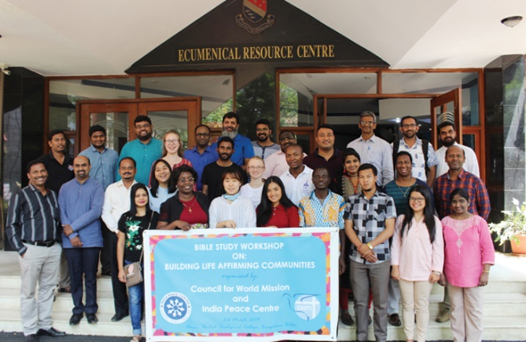

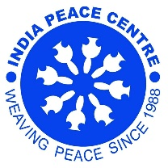
Face-2-Face 2023

Building Life-Affirming Communities
Peace-making in Places of Inequality and Plurality
20th September – 29th October 2023
Nagpur and New Delhi, India
_________________
** Call for Applications **
Peace-making in a pluralistic global environment requires understanding of difference and convergence. To better understand world-views and build relationships of respect, CWM organizes cross-cultural exchange and inter-religious learning.
Participants in the six-week Face2Face programme immerse themselves in the religious diversity of India. Together, we prepare for mission and ministry in a diversity of cultural, social, theological and contextual realities. We seek to understand and engage with how the fullness of life is being denied to the large majority of the world’s population. Students reflect on both motivations and methods of mission intersect in different parts of the world, and bring this back to their own contexts.
Using a variety of encounters, pilgrimage, reflection and seminars, this is an opportunity for students to reflect on doing mission in the context of a vibrant, multifaith society, in a post-colonial context. Participants must come with a desire to love the neighbour who is different, discover a common humanity, and seek ways of working for peace with ‘the other’.
Fr Aloysius Pieris (born 9 April 1934) is a Sri Lankan priest, liberation theologian and the founding director of the Tulana Research Centre for Encounter and Dialogue. He argued some years ago that liberation theology in Asia needed to take into account both the contextual realities of poverty and multifaith. Doing theology in India needs us to identify the economic divides and religious ones, as we seek common ground and possibilities for intersection. Too often, religions have been used both to legitimize exploitative poverty and the accumulation of wealth while prophetically critiquing sinful systems of exploitation and destruction of humanity and creation.
This year’s programme will be based at the India Peace Centre in Nagpur and will include a visit to New Delhi and Agra. Participants will learn about a range of faiths (Hinduism, Buddhism, Jainism, Sikhism, Islam, Baha’i) and encounter the lived realities of local populations. Alongside exposure visits, the community of students will reflect biblically and theologically, bringing global perspectives to local experiences. We will read the Bible in the context of poverty and engage in interfaith dialogue. Bible Studies workshops will offer tools for reading the biblical texts through different lenses.
Objectives
- To enable theological students to engage in a global dialogue on theology, spirituality and mission
- To enable intercultural and interreligious exchange and theological reflection
- To facilitate immersion, bible studies and seminars enabling students to reflect on mission in the context of Empire and post-colonialism
- To engage students with a specific Asian context of poverty and religious pluralism
Expected Outcomes
- A series of thematic Sessions on different religious practices and understandings (with associated exposure visits), leading to
- Online reflections (website, social media, etc) - updated regularly by the students
- Contributing towards the development of a global network of young theologians
- Offering local students and communities the richness of inter-cultural exchange
Who
- Participants are students of theology, either current or recently graduated (not yet ordained).
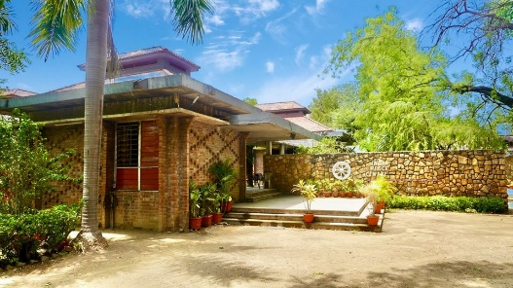
When
- 20th September – 29th October 2023
Where
- India Peace Centre, Nagpur
- New Delhi / Agra [10 days]

About
CWM Education Formation and Empowerment administers the Face 2 Face Programme. The implementation responsibilities are shared between CWM, the sending church/college, the host Centre and the participants.
CWM will cover international travel, accommodation and meal expenses. Participants need to cover their own passport and visas (including any transit visas). They may seek assistance from their Church/College (as CWM does not process or cover passport/Visa related costs). Participants will need to bring extra spending money for expenses outside those covered by CWM. They are expected to prepare an individual paper under the guidance of a college advisor, which critically reflects on their experience. This Programme is not designed to form part of any other degree or diploma course, however, the paper may be included in the assessment process for the participant’s academic coursework, subject to prior agreement with the participant’s home college. CWM may also consider these papers for publication.

How to apply
Interested applicants should contact the General Secretary of their Church or the Principal of the Theological College directly for referral/endorsement.
Application forms may be downloaded from the CWM website at www.cwmission.org
Please Note: Only applications with a General Secretary or College Principal endorsement can be received.

APPLICATIONS OPEN JUNE 7, 2023
APPLICATIONS CLOSE JUNE 21, 2023
Email empowerment@cwmission.org for details.

More details – for Applicants
- Due to the need for applicants to apply for visas and for CWM to book flights, the application deadline is unable to be extended. If you need help with your application, please contact us before the deadline.
- This programme includes the following units of study: understanding Hinduism, Buddhism, Jainism, Sikhism, Islam, Baha’I; and seminars on: overcoming religious prejudices, peace and religious pluralism, interfaith understandings of peace and justice.

More details – for Sponsoring Colleges and Churches
- Due to the need for applicants to apply for visas and for CWM to book flights, the application deadline is unable to be extended. If you need help with your application, please contact us before the deadline.
- This programme includes the following units of study: understanding Hinduism, Buddhism, Jainism, Sikhism, Islam, Baha’I; and Seminar Days on: overcoming religious prejudices, peace and religious pluralism, interfaith understandings of peace and justice.

