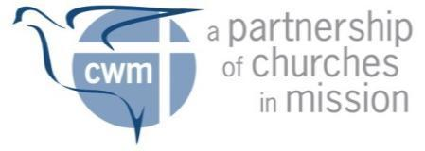
CWM Programme

PART C

Medical Examination

Name
Date of Birth |  |  |  | Age |  | Gender
Pulse rate |  | Blood pressure |  | Height |  | Weight
Emergency Contact Numbers. Please provide two (2) emergency contacts.
Full Name
Relationship
Daytime phone number |  | Mobile number
Postal address
Email
Full Name
Relationship
Daytime phone number |  | Mobile number
Postal address
Email

Do you need any mobility assistance?
If yes, please give details.
Do you have any disabilities CWM should be aware of? give details.
Do you have known allergies?
give details.
Are you aware of any medical conditions that may hinder your participation to the Scholarship Programme? give details.
Special Dietary Requirements

IMPORTANT: To be completed by Attending Physician.
Any family history of disease?
Any serious operations, injuries or illness in the past?
Any infectious diseases?
Any eye defects? If yes, are spectacles worn and satisfactory?
General condition
Any ear disease/s?
Are mouth and throat healthy?
Teeth are well cared for?
Are heart and lungs healthy?
Result of chest X–ray
Any signs of hernia?
Urine: Any albumen? Any sugar?
Any organic, nervous or other disorders?
Any functional disorders?
Is the applicant emotionally well-balanced?
Is there any tendency to depression or history of it?
Have you any knowledge of the applicant’s lifestyle and is there any evidence of abuse of alcohol or drugs?
Do you consider that there are any medical reasons why the applicant should not go abroad for further training?
Does the applicant need any special diet or regular medical treatment of any kind?

ATTENDING PHYSICIAN’S CERTIFICATION

I hereby certify that ______________________________________ is physically fit / unfit to participate in the Academic Accompaniment Programme of the Council for World Mission.

___________________________________________
Signature over Printed Name of Attending Physician
Date _______________________
Registration No. _______________________

